

ABC Awards Level 2
Motor Vehicle Studies

Underpinning Knowledge Evidence Record

D/601/6171 Knowledge of Health, Safety and Good Housekeeping in the Automotive Environment

Learners Name
ABC Awards Registration Number
Centre Name
Assessor 1 Name
Assessor 2 Name

DECLARATION OF AUTHENTICITY

This declaration must be completed and signed by the learner and countersigned by the tutor / assessor and covers all evidence submitted for moderation.

Learner Name
Unique Learner Number (ULN) |  | ABC  Learner Reg. ID
Qualification Title
Centre Name

Learner statement of authenticity

Before signing please read the guidance below.

I confirm, that the attached assignment / portfolio is all my own work and does not include any work completed by anyone other than myself. I have completed the assignment / portfolio in accordance with ABC Awards’ instructions and within the time limits set by my centre.

Signature |  | Date

Centre confirmation of authenticity

On behalf of …………………………………….(insert centre name), I confirm that the above mentioned learner, to the best of my knowledge, is the sole author of the completed assignment / portfolio attached, and the assessments have been completed under the required conditions.

Signed |  | Date
Name
Title

Guidance for Learners

You have been asked to sign this Declaration of Authenticity and place it at the front of your portfolio or course work assessment. It confirms that the work you have submitted for assessment is your own and that you have not copied it from someone else or allowed another learner to copy it from you.

When preparing any course work it is good practice to undertake research using information from published sources. If you quote directly from these sources then this must be indicated in your work by using quotation marks and referencing the document from which the quotation was taken. You must then comment in your own words on any ideas expressed.

Assessors, internal verifiers and ABC Awards’ external moderators and verifiers are subject specialists who can spot the use of published materials that may be passed as your own words or ideas.
If you do copy words from a published source and do not indicate their reference you will be committing plagiarism. This is considered a form of cheating and may result in your assessment being declared void.

Contents

Task No | Title | Assessment Criteria
1 | Personal PPE | 1.1
2 | Vehicle protective equipment | 1.2
3 | Roadside assistance | 1.3
4 | Cleaning work environment | 2.1, 2.2, 2.4, 2.5, 2.7
5 | Minimising waste | 2.3, 2.6
6 | Health and safety legislation | 3.1, 3.2
7 | Hazardous substances | 4.6
8 | Hazard and risk | 4.3, 4.3
9 | Fire extinguishers | 4.4
10 | Warning signs | 4.5
11 | Workplace policies | 3.4, 4.2

Task 1 – Personal PPE | Assessment Criteria 1.1

Personal protective equipment (PPE) is defined as ‘all equipment (including clothing affording protection against the weather) which is intended to be worn or
held by a person at work and which protects them against one or more risks to
their health or safety’,

Below are examples of PPE worn or used in the motor vehicle environment.

Complete the table by naming the PPE indicated and stating what it will protect the wearer/user from
PPE | Name | Why worn/used
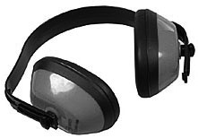
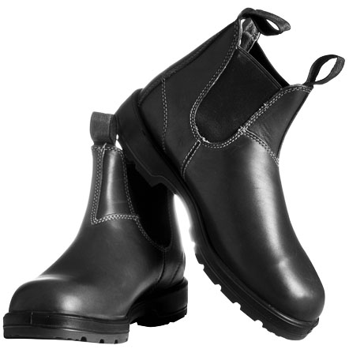

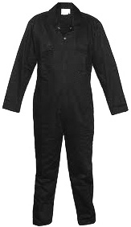
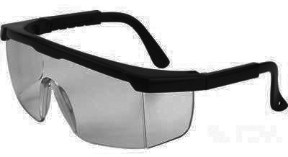
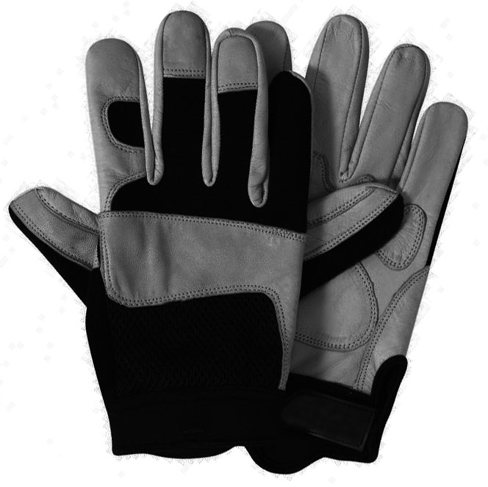
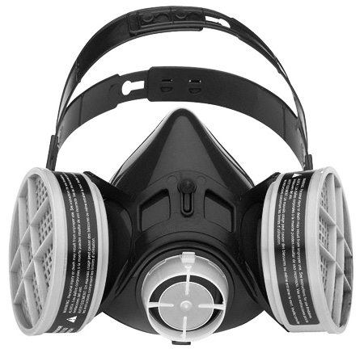
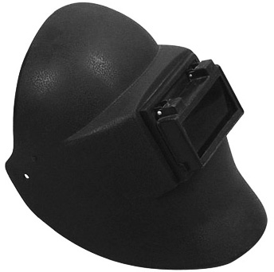

Task 2 – Vehicle protective equipment | Assessment Criteria 1.2

Whilst working on a vehicle in a motor vehicle workshop it is important to protect that vehicle from damage or contamination by using vehicle protective equipment (VPE)

Complete the table below by identifying the protection offered by the VPE listed
VPE | Protects vehicle from
Wing covers
Seat covers
Steering wheel cover
Disposable floor mats

Task 3 – Roadside assistance | Assessment Criteria 1.3

Attending a vehicle at the roadside can be very dangerous, it is recommended that a motor vehicle technician that is expected to work in this situation be specially trained.

Below are points that need to be considered when working at the roadside.

Complete the table by giving a reason for the points raised
Safety points | Reason
Type of road
(motorway, dual carriageway, narrow road)

Vehicle position
(on the carriageway, hard shoulder, lay-by)

Road visibility
(day, night, well lit, not lit)

Weather conditions
(wet, dry fog )

Breakdown vehicle position
(recommended as in-line with traffic flow behind the stranded vehicle)
Spillage of fuel or oil

Stranded vehicle occupants position

Wearing the correct personal PPE is also important in this situation.
List THREE items of PPE that would be used when attending a vehicle at the roadside
1:
2:
3:

Task 4 – Cleaning work environment | Assessment Criteria 2.1, 2.2, 2.4, 2.5, 2.7

Keeping the workshop environment clean and tidy is very important.
List 3 reasons why the workshop should be kept clean
1:
2:
3:

Particular housekeeping tasks are performed at the start and end of the day. Complete the table below outlining 3 tasks that are carried out in your workplace or training workshop
Task | Start of the Day | End of the day
1:
2:
3:

Tools and equipment should be cleaned and maintained to ensure they operate correctly.
Complete the table below by describing the checks and cleaning method for the groups of tools and equipment shown.
Tools | Cleaning and maintenance
Hand tools
Air tools
Jacks and vehicle lifts
Electrical tools
Electrical equipment

In all motor vehicle workshops, spillages of liquids will occur from time to time
List below the procedure for dealing with spillages in your workshop
1:
2:
3:

Task 5 – Minimising waste | Assessment Criteria 2.3, 2.6

Minimising waste can help the company reduce costs and improve profitability
Waste can mean the utilities and consumables used as well as the disposal of used parts.

Explain how the following can be best utilised to reduce costs
1. Workshop heating

2. Workshop lighting and power usage

3. Consumables
(nuts, bolts washers etc)

During normal maintenance and repair of motor vehicles waste products are produced
Explain how the following could be disposed of whilst reducing the impact on the environment
1. Metals

2. Cardboard and paper packaging

3. Waste oils

4. Plastics

Task 6 – Health and safety legislation | Assessment Criteria 3.1, 3.2

The basis of British health and safety law is the Health and Safety at Work etc
Act 1974.

The Act sets out the general duties which employers have towards employees and members of the public, and employees have to themselves and to each other.
Refer to the act and outline THREE duties of the employer and employee in the table below
Duty | Employer | Employee
1:

2:

3:

Task 7 – Hazardous substances | Assessment Criteria 4.6

Motor vehicle repair often involves working with substances that are hazardous to health.

The Control of Substances Hazardous to Health (COSHH) Regulations 2002 is the law that requires employers and employees to ensure that hazardous substances used in a workplace do not affect adversely the workforce or others.

Substances that are hazardous usually have a warning symbol on the packaging. Some common symbols are shown below
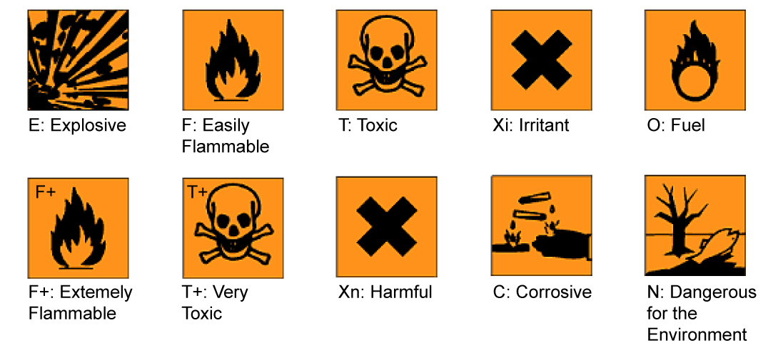
Investigate the products used in your workshop and identify THREE substances that would come under COSHH regulations
1:
2:
3:

Task 8 – Hazard and risk | Assessment Criteria 4.3, 4.3

Definitions

HAZARD Anything that has the potential to cause harm

RISK The chance or probability that a hazard WILL cause harm

Look at the motor vehicle workshop layout shown below and circle 6 HAZARDS that you see.

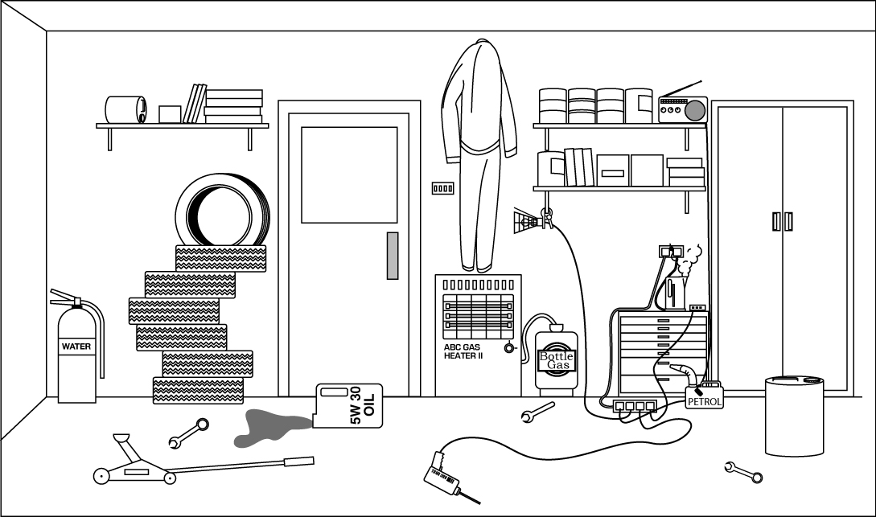

Having identified the hazards, the risks must be considered

Choose THREE hazards and complete the table below by outlining what risk they pose and what could be done to reduce this risk
Number | Hazard | Risk | Risk reduction
1
2
3

Task 9 – Fire extinguishers | Assessment Criteria 4.4

All motor vehicle workshops will have fire extinguishers placed in them, but not all extinguishers are suitable for some types of fire.

Investigate the fire extinguishers in your workshop and complete the diagram below by indicating the type of extinguisher suitable for each type of fire.

The first one has been completed to help you

TYPE OF FIRE | 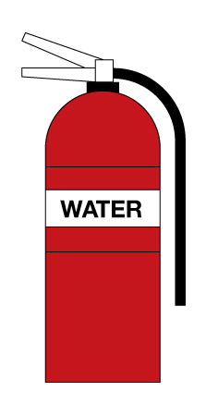 | 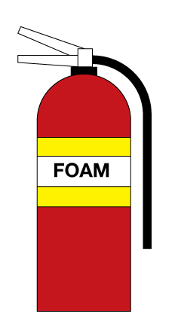 | 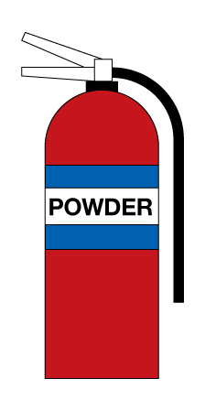 | 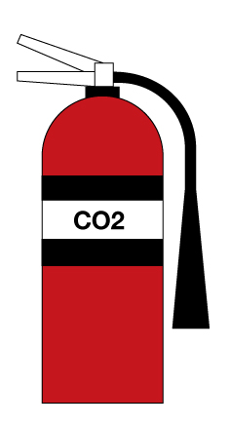
Type A  Paper, Wood, Textile and Fabric | a
Type B
Flammable Liquids

Type C
Flammable gases

Type E
Electrical Equipment

Task 10 – Warning signs | Assessment Criteria 4.5

Safety signs and colour are useful tools to help protect the health and safety of employees and workplace visitors. The shape and colour of signs determines the type of warning given

Below are 4 types of safety sign and their description.
Investigate warning signs in your workshop and insert TWO examples of each type in the space provided.

Prohibition (Must NOT) | Example 1 | Example 2
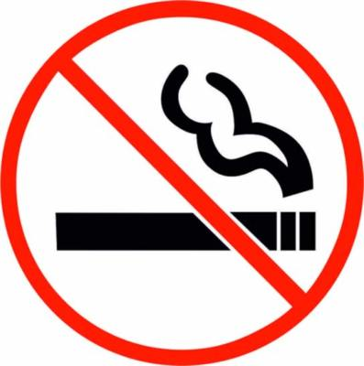
Round shape, red edging and diagonal line, black pictogram on white background
Mandatory (Must DO) | Example 1 | Example 2

Round shape, white pictogram on blue background
Hazard Alert (Warning) | Example 1 | Example 2
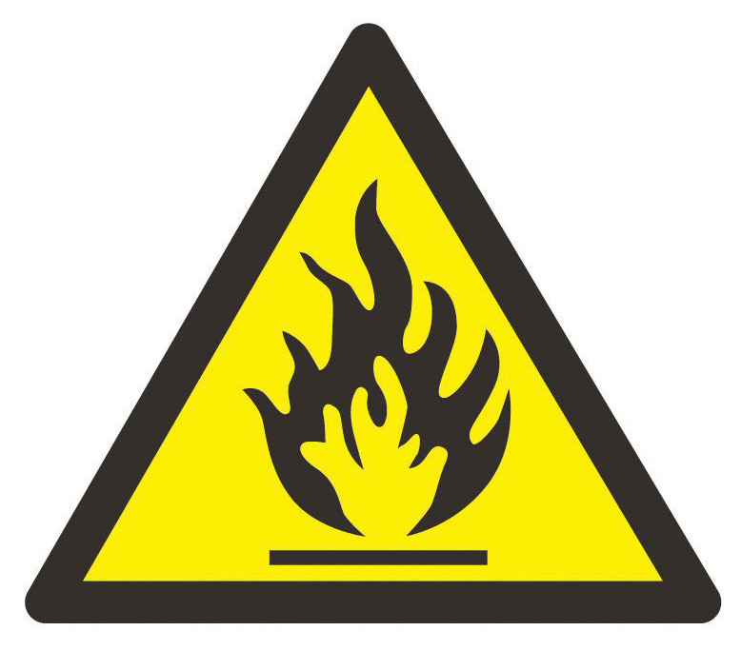
Triangular shape, black edging
pictogram on yellow background
Safety Information (Safe situation) | Example 1 | Example 2

Rectangular or square shape
white pictogram on green background

Task 11 – Workplace policies | Assessment Criteria 3.4, 4.2

To ensure they comply with health and safety, companies have rules (known as policies and procedures) that employees are expected to follow

What are your company’s (or training company) rules with regard to:
Protective clothing you are expected to wear
Smoking in the workshop
Eating and drinking in the workshop
Moving Vehicles
Reporting accidents

Unless otherwise stated e.g. for some entry level qualifications, learners can work together but should identify sections which are their own work.

